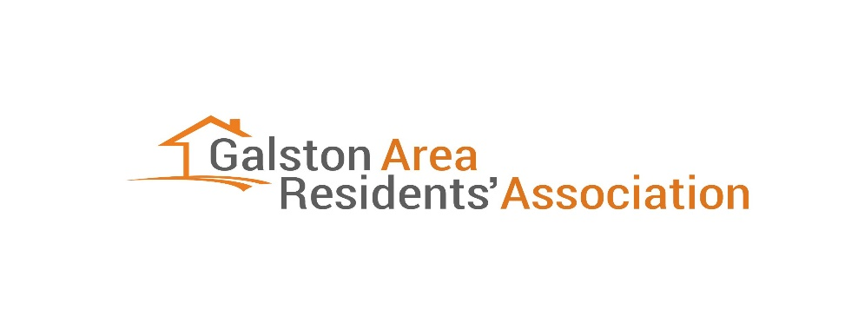

**Application For Membership**

I, _________________________________________________________________________

(Full Name)

Of ________________________________________________________________________

( Address)

Apply for membership of the Galston Area Residents’ Association Inc (GARA)

Contact email: ______________________________________________________________

(please print)

Phone Number: ______________________________________________________________

Annual Membership Fee of $20.00 covers all members of a household. **The fee can be paid by direct bank deposit to the Galston Area Residents Association BSB633000 Account Number 116881087. Please include your name and the word “Membership” to the transaction description.**

Signature of Applicant: _____________________________ Date:____________________

Membership Forms can be returned by email to [galstonareara@gmail.com](mailto:galstonareara@gmail.com) or by post to address below.

As soon as practicable after receiving an application for membership, the Secretary will refer the application to the Committee, who will determine whether to approve or reject the application. You will be notified of the outcome.

John Inshaw, Secretary.

__________________________________________________________________________________**Office Use Only**

Nominee approved or rejected by Committee: ______________________________

Entered Into Membership Register ______/______/_____ Secretary Sig. ____________

__________________________________________________________________________________

**POSTAL ADDRESS: GARA, 33 ARCADIA ROAD, GALSTON. 2159. NSW.**